**Sentiment Classification (SST-2)**

**Google Colab Link:**

[**https://colab.research.google.com/drive/146lvO8qSj5ElBY2rMn5gtFqRozeolQSn?usp=sharing**](https://colab.research.google.com/drive/146lvO8qSj5ElBY2rMn5gtFqRozeolQSn?usp=sharing)

**Dataset preparation from SST-2:**

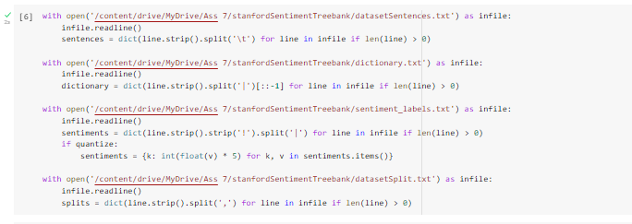

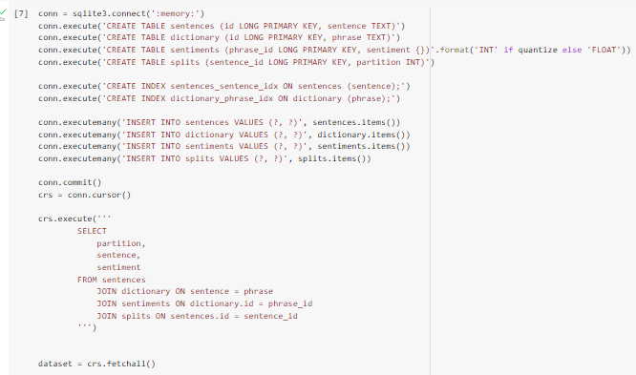

**Data Pre-processing:**

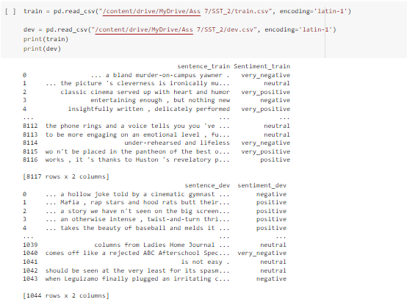

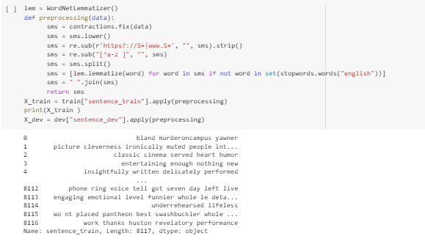

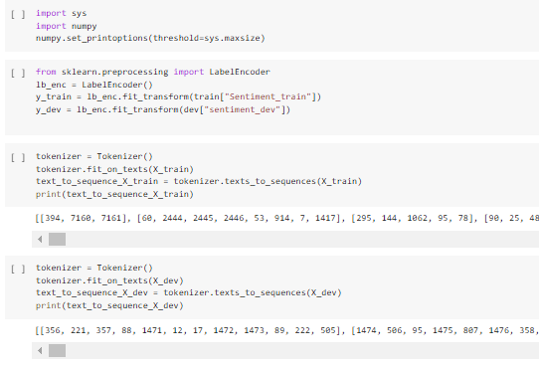

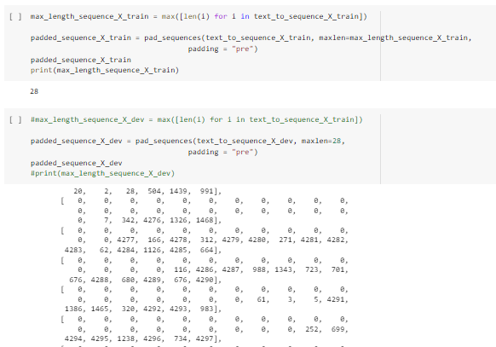

**Trail Model-1**

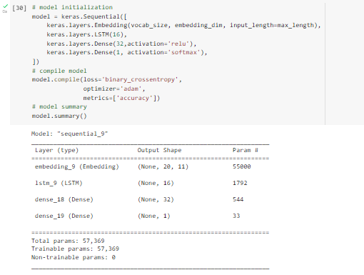

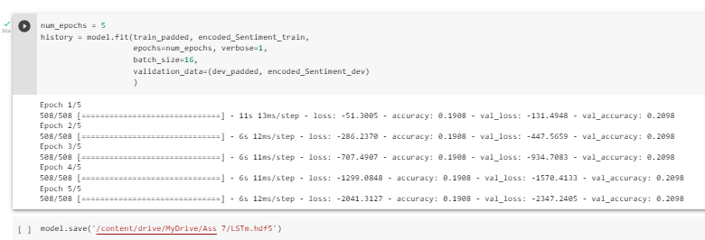

**Trail Model-2**

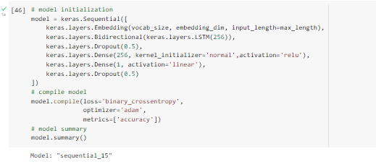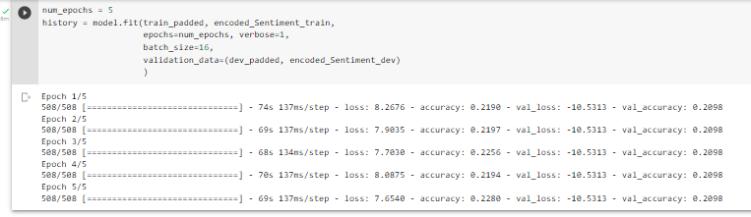

**Trail Model-3**

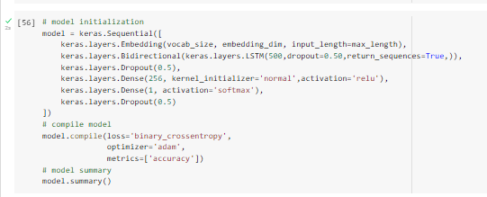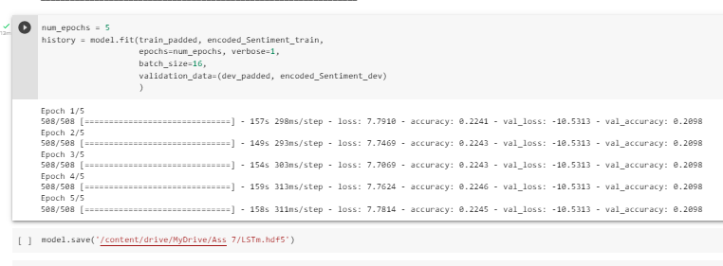

**Trail Model-4**

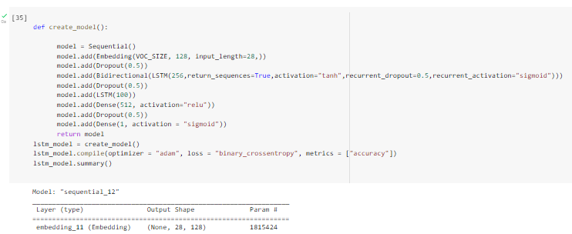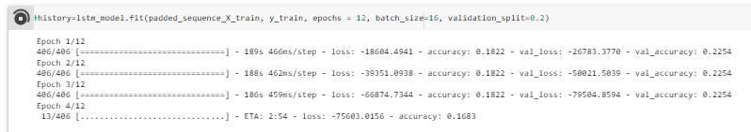

**Final Model:**

**Experimental Results:**



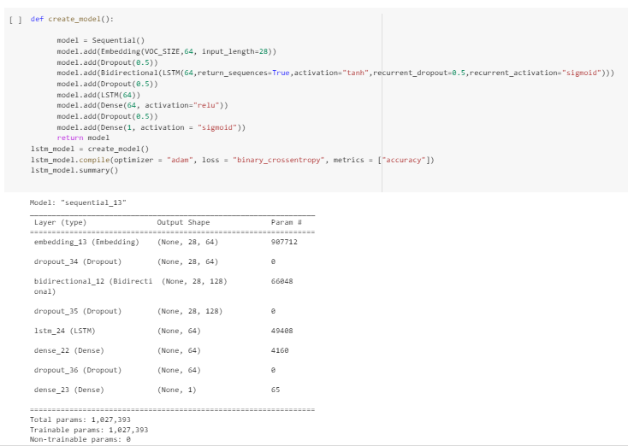

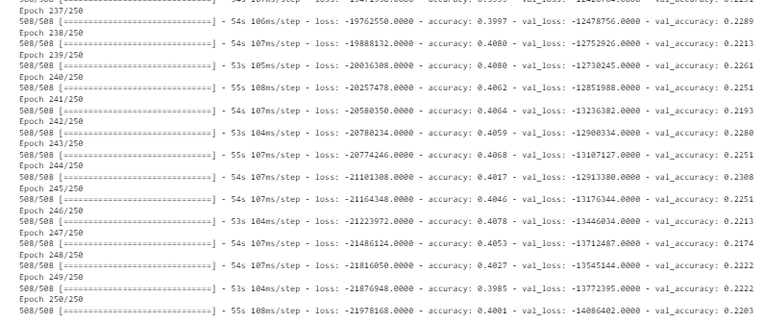

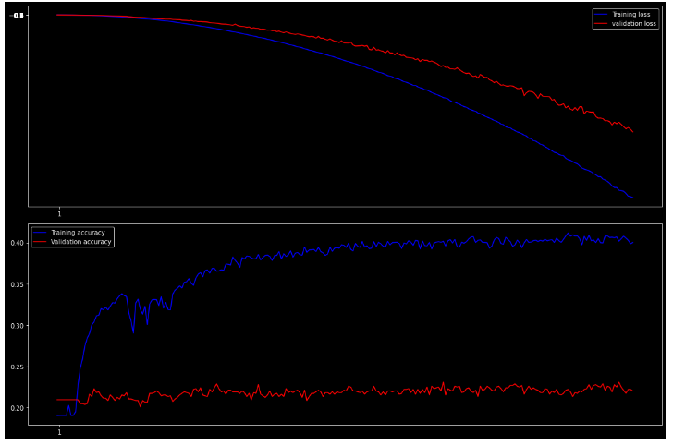

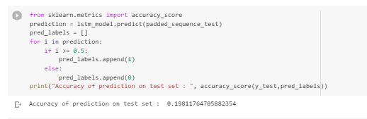

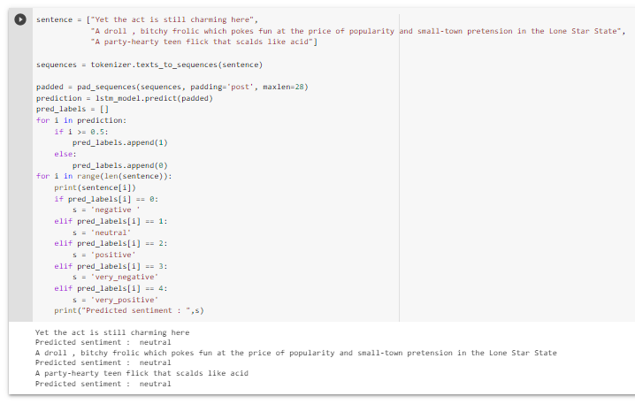

**Comparison between Models:**

|  |  |  |  |  |  |  |  |  |  |
| --- | --- | --- | --- | --- | --- | --- | --- | --- | --- |
| Model | Total Layer | Embedding | LSTM | Bidirectional_LSTM | Dense_layer | Dropout | optimizer | accuracy | Val_accuracy |
| Model 1 | 4 | 1 | 1 | NA | 2 | NA | adam | 19 | 20 |
| Model 2 | 6 | 1 | NA | 1 | 2 | 2 | adam | 22 | 20 |
| Model 3 | 6 | 1 | NA | 1 | 2 | 2 | adam | 22.45 | 20 |
| Model 4 | 9 | 1 | 1 | 1 | 2 | 4 | adam | 18 | 22 |
| Final Model | 9 | 1 | 1 | 1 | 2 | 4 | adam | 40 | 22 |

